Product Specification
Major parameter & Functions |  | Details
Sensor | Specification | 1/2.7” CMOS
 | Model | K04
 | View angle | Horizontal 360°, vertical 360°, panoramic view without dead angle
 | Digital noise reduction method | Support DNR、3DNR
Chip | Chip model | CV1821
Lens | Field of view (D/H/V) | 180°/180°/180°
 | Aperture | F2.2
 | Focus length | 1.05mm±5%
Compression Standard | Video compression standard | H.265 / H.264
 | Compression output bit rate | 80Kbps-1.5Mbps
Image | Maximum image size | 2560*1440
 | Support resolution ratio | 2560*1440,1920*1080, 640*480
 | Frame rate | 15fps
Network Function | WIFI module | 8189FTV
 | Interface protocol | Rtsp
 | Support protocol | TCP/IP,ICMP,HTTP,HTTPS,FTP,DHCP,DNS,DDNS,RTP,RTCP
Interface | Tf card slot | Maximum support 128G
 | Network interface | RJ45
 | Power interface | DC 5V/1A interface
 | Audio interface | 3.5mm audio interface
General Specifications | Operating temperature and humidity | -10℃~50℃, humidity less than 95% (without condensation)
 | Installation method | Bracket installation, wall mounting
 | Power consumption | <10W MAX
 | Infrared light | Diameter 5-10m (depending on the environment) 8 infrared lights
Main Functions | Motion detection | Support
 | Voice detection | Support
 | Retransmission in case of network disconnection | Support
 | Cloud playback/card playback | Support
 | Infrared night vision | Support

Product Photograph
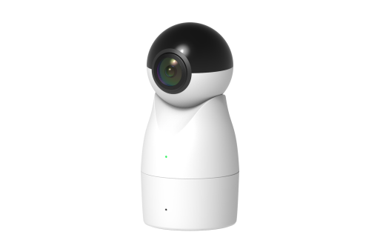 | 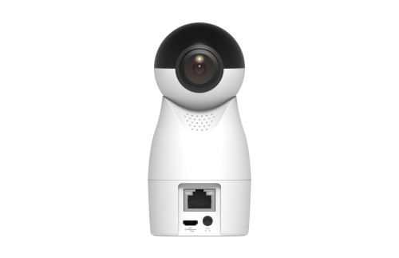
Front | Back

